GPON ONU

* OP15X Series
* Product specification

Version 1.0

Mar, 2013

All Rights Reserved

DIRECTORY

OP15X SERIES Overview 4

ONU OP15X series components 4

To reset the ONU 5

Management 5

Register OLT 6

**Using SN in ONU to register OLT.** 6

**To set ONU SN** 6

Web login 9

Factory mode 10

Network configure 10

**WAN connection** 11

Bridged 12

Router 16

**WLAN Configure** 20

Introduce 20

Creating WLAN connection 21

**TR69** 22

Introduce 22

ITMS server 22

IP address 22

Port 22

Set ITMS server configure 23

**QOS config** 23

QOS 23

Set QOS configure 24

Security 24

**URL filter** 25

Config URL filter 25

**Firewall** 25

Configure firewall 26

**MAC filter** 26

Configure MAC filter 27

**IP filter** 27

Configure IP filter 29

Application 29

VOIP 29

Basic Setup 29

Log Plot Setup 32

Voice Media 33

SIP Application 33

**IGMP** 34

IGMP Settings 34

Enable IGMP Snooping 35

Diagnosis 35

**Line Diagnosis** 35

Ethernet connection Test 35

**Ping Test** 36

**Inform Test** 36

# OP15X SERIES Overview

* The ONU OP15X Series (ZISA Network Interface Device) is a family of indoor, full-featured gateways for residential installations. These next generation ONUs support GPON or Active Ethernet termination to meet the demands of multi-service network deployments to the user. With either GPON or Active Ethernet uplinks, the OP15X Series ONUs deliver data, voice, or video (IPTV) over fiber.
* Compliant to The ONUs is a full-featured gateway supporting services such as DHCP server, rate limiting, filtering, comprehensive logging, and more. The ONU product line implements a very flexible QoS allowing the service provider to guarantee that services are being prioritized correctly and the end-user receives the Quality of Experience that is expected.
* The ONU OP15X series may be managed by
* TR069
* Web (HTTP)
* Command Line Interface (CLI/Telnet)
* ONT Management Control Interface (OMCI) *for GPON only*

# ONU OP15X series components

Depending upon the model selected, the interfaces include:

* two, or four Gigabit Ethernet ports
* Two Phone Ports (POTS)
* four wireless ports
* USB port

# To reset the ONU

Press a pin into the reset button and hold it down until all LEDs are on together.

* Release the reset button.

# Management

* CLI

The OP15X products can be managed using a command line interface.

* Web

The OP15X products can also be fully managed through the web (HTTP)

interface. The web pages are very intuitive and they include a context sensitive help button for additional information. The web interface will be used for the configuration examples used in this document.

* TR069

The OP15X products can also be managed through tr069. The OP15X family is compatible with any industry standard tr069.

* OMCI

ONU Management Control Interface (OMCI) provides policy based configuration and management capabilities for GPON. OMCI management is intergrated into the OLT command set, so configuration of the ONU with OMCI is done from the OLT, not directly as with the Web UI or CLI interfaces.

# Register OLT

* Access on the GPON interface requires a Registration ID. This value must

match the value programmed in the OLT. The system administrator should

have programmed this value. Changing the value will disable communications with the network. The unit will reset once the Reg ID has been changed and the GPON link will not communicate with the OLT until the same password is entered in the OLT.

## **Using SN in ONU to register OLT.**

## **To set ONU SN**

* telnet ONU ;such as telnet 192.168.1.1， username and password are admin/admin

or twmanu/twmanu

* set sn or password.

OP151：

T&W#

T&W# man

T&W# manufactory

manufactory#

manufactory# set sn

<string> format:CCCCXXXXXXXX

manufactory# set sn ALCLf9c1fbde

.set sn success!

manufactory# write password hex f201300055902600

.Write password success!

OP156：

BCM99999 Broadband Router

VosLogin: admin

Password:

S304# man

S304# manufactory

MANUFACTORY# write  sn

  <string>                      format:CCCCXXXXXXXX

MANUFACTORY# write  sn aaaaaaaaaaaaaaaa   //16 HEX char

SN formate: 4 vendor ID, 8 serial ID sample: TWSH01020304

MANUFACTORY# write  oltpassword  hex 1111122222333334444455555   //20 HEX char

Password formate: 20 hex value; sample: 00112233445566778899

* restart onu, the new SN will take effect.

# Web login

* The default IP address of device is 192.168.1.1. we need congfigure ONT on the web (<http://192.168.1.1/login.html>). The default Username is ‘admin’，and password is ‘admin’

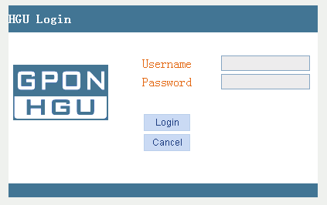

# Factory mode

* The factory default screen allows you to recover factory configuration.

Clicking recovery factory set button on the Management | factory default page will recover configuration of ONU to factory configuration

**Figure 2: The factory mode**

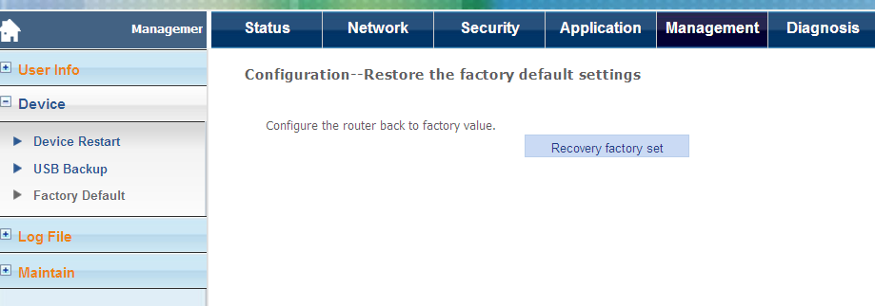

# Network configure

* The network pages define and configure wan connection by the ONU, such as WAN, LAN , WLAN and QOS. The System pages also provide options for binding, by port or vLan.

**Figure 3: The network menu**

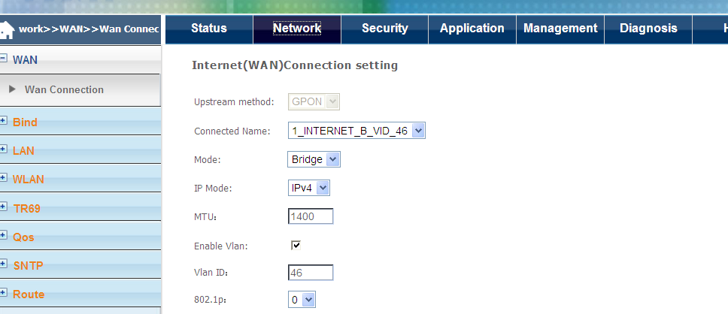

This section describes the following network pages:

* Wan connection
* Bind
* LAN
* WLAN
* TR069
* Qos
* SNTP
* Route

## **WAN connection**

* The Deployment scenarios section is a task based section which describes

how to create data, video and voice connections.

### Bridged

* For bridged VLANs, an IP Address can be assigned if the ONU will be a host in a particular IP subnetIP addresses for LAN-side client devices can be statically assigned or assigned by an upstream DHCP server. Any number of Ethernet ports or WiFi SSIDs can be members of the Bridged VLAN All clients in a bridged VLAN will be in the same IP subnet, and the OP15X will enable direct local peer-to-peer communications between all clients unless the Secure Forwarding option has been enabled. If Secure Forwarding is enabled, all broadcast traffic is forwarded upstream and not flooded out the other local ports in the VLAN. This prevents local peer-to-peer communications, and is equivalent to the ONU operating mode Bridged with CPU or CPU-Bridged must be selected for using bridged VLANs in Dual Managed mode with VEIP.

**Figure 4: For bridged connections all the interfaces are in the same subnet**

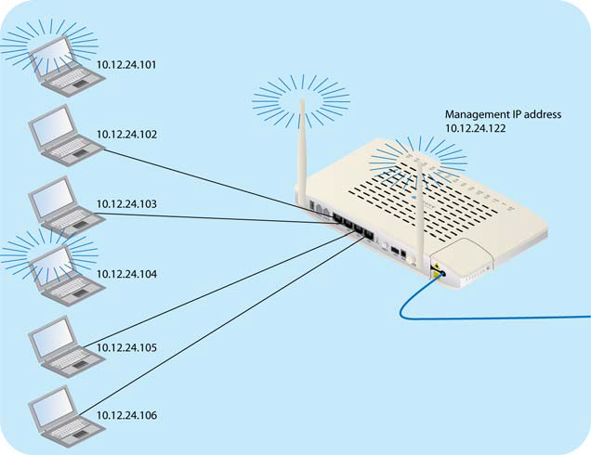

#### To create a bridged connection

**Figure 5: wan bridge connection page**

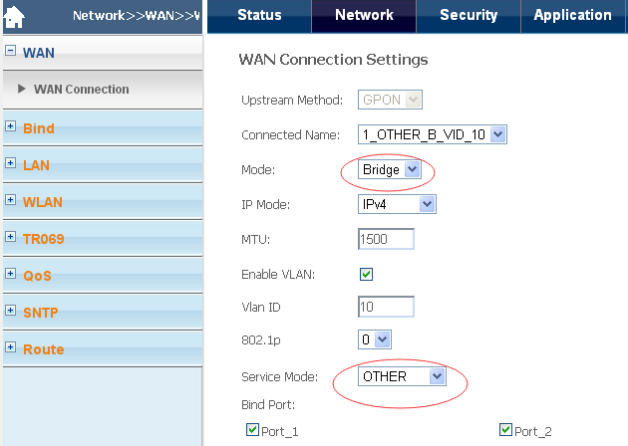

* On the| wan connection page, click Add New VLAN in drop down box of connection name.
* In the mode text box select the bridge
* In the IP mode text box select the IP protocol.
* In the VLAN ID text box enter a VLAN ID(1 - 4095)
* From the service mode dropdown select service type.
* From the service mode dropdown select the bind port
* Click Apply/Save

**Notes:**

In bridge mode,‘OTHER’should be checked in Service mode box. So user’PCs get IP address from PPPOE(dail-up internet mode) or other DHCP server .

Besides,you can check wireless Box in Bind Port. After wireless cards access to ONU’s SSID, PC can dail-up internet by PPPOE

#### Check bridge connect status

**Figure 6: check bridge connect status**

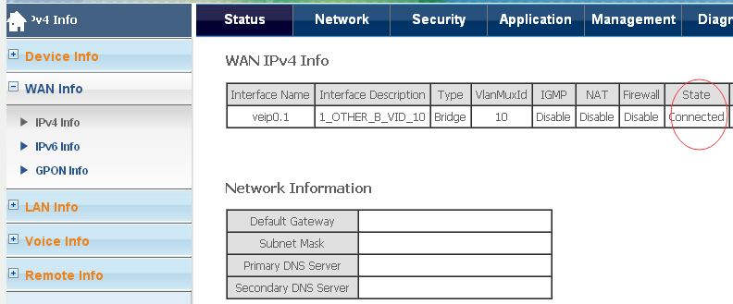

### Router

* For Router VLANs, an IP Address will be assigned per physical port that

is assigned to the VLAN. The minimum configuration will have the uplink interface and at least one LAN-side interface. When there are multiple LAN ports in the same Router VLAN, each one must be assigned its own IP subnet

* In the illustration below, a NAT Router VLAN has been configured that contains three LAN ports and one SSID. A total of six IP addresses are assigned to the 2426 for this configuration. A WAN IP address is assigned the uplink, and four LAN-side IP addresses

must be assigned, each in a separate subnet, plus an IP subnet for the WiFi interface.

* All Wi-Fi connected client devices will be in the same subnet. An RG configuration item called “Isolate Clients” in the Wireless / Basic menu determines if these devices will be able to communicate locally with each other, or if all traffic will be forwarded upstream. When Isolate Clients is enabled, all traffic is forwarded upstream, blocking local peer-to-peer communications.
* The example below shows a Router VLAN with NAT. When NAT is enabled, the Router performs Network Address Translation, mapping each LAN side IP address and source port to a unique protocol port used with the WAN IP Address for communications across the network

**Figure 7: For router connections each interface is in its own subnet**



#### Creating router connections

**Figure 8: Creating a router**

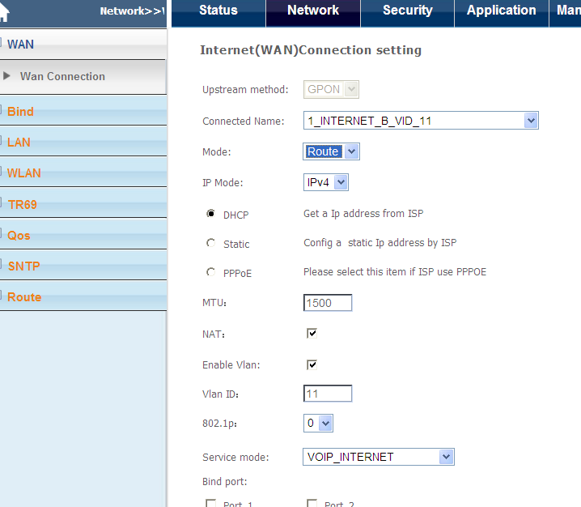

* On the Configuration| wan connection , click Add New VLAN in drop down box of connection name.
* In the mode text box select the Route.
* In the IP mode text box select the IP protocol.
* In the VLAN ID text box enter a VLAN ID(1-4095)
* From the service mode dropdown select service type.
* From the service mode dropdown select the bind port ‘
* Click Apply/Save

#### Check router connections

**Figure 9: router connection status**

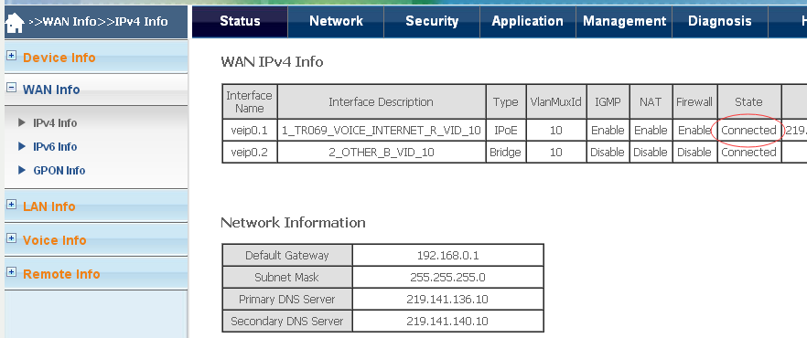

## **WLAN Configure**

### Introduce

* Open Wireless:

If you want to make wireless effective, you have to put this check box selected, otherwise hidden Access Point SSID, Country, Enable Wireless Guest Network, and Guest SSID option will not be displayed.

* Hidden Access Point

If you want to hide the access point to your router, you must put on the marquee. In this case, the configuration will not be able to get through the passive scan SSID.

* SSID

SSID (Service Set Identification) is a unique name shared in the wireless network, The SSID for all devices in the network must be the same.

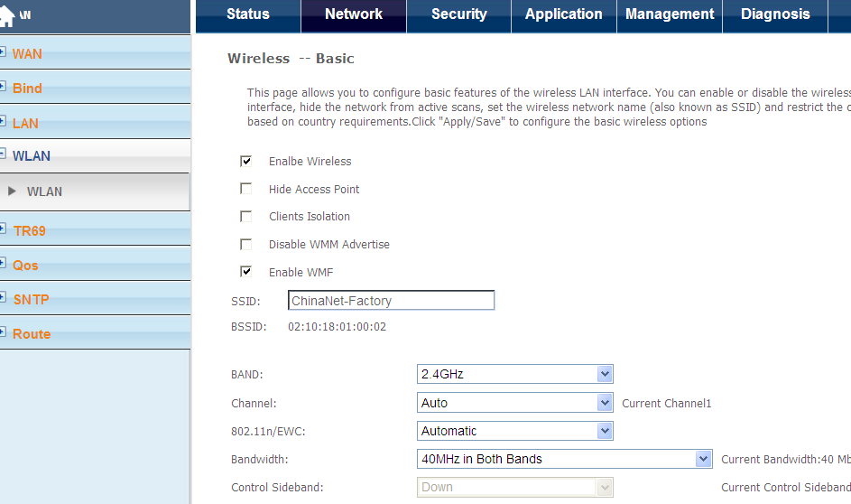

### Creating WLAN connection

1. enable wireless
2. set ssid name in ssid text box.
3. set the channel ,bandwidth and so on. if you not set ,it will be valued as default.
4. Click Apply/Save

## **TR69**

### Introduce

### ITMS server

Remote management allows you to make configuration settings from WAN (Wide Area Network) client by Web browser. Access browser interface still requires a user name and password to login.

### IP address

Access Internet router IP address. If the specified IP address is 0.0.0.0, then all the hosts can be connected to the DI-624 + A for configuration settings.

### Port

Access to the router port number. Example:http://x.x.x.x:8080 ????x.x.x.x is the router's WAN IP address, 8080 is the Web-management interface port.

### Set ITMS server configure

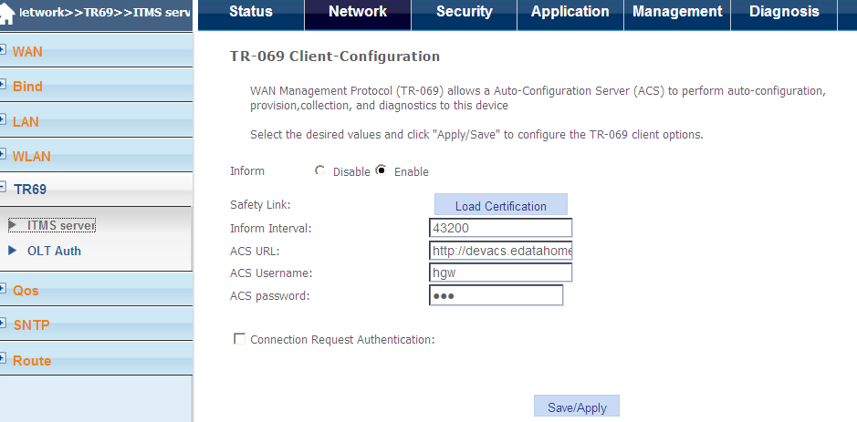

1. Enable inform.
2. set ITMS address int ACS URL.such as

<http://80.80.80.80:9090/ACS-server/ACS> 80.80.80.80 is itms server ip, 8080

is connect port

1. set itms server name and pass.
2. Click Apply/Save

## **QOS config**

### QOS

* QoS is a network security mechanism is used to solve issues such as network latency and blocking a technology, QoS refers to the messaging throughput, delay, delay jitter, loss rate performance.

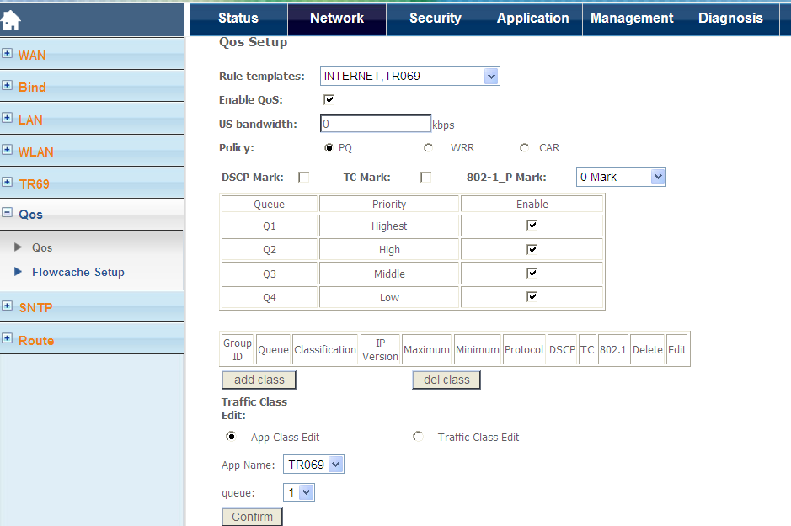

### Set QOS configure

1. Set one Rule template in rule template drop down box.
2. Enable QOS in group box.
3. Set the policy for queues.

# Security

## **URL filter**

* Use URL refused to the LAN to access a particular Web client computer side. URL is a specific schedule for the regional network and a string. If any section of characters in the URL included in the block will not be accessed. If any section of the URL contains the word in the block, the page will not be displayed.

### Config URL filter

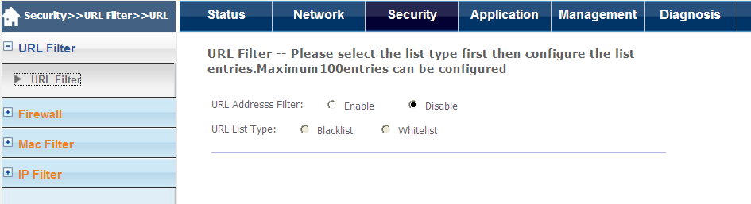

1. Select the group box to enable URL filter.
2. Select the filter type: blacklist or whitelist.
3. Click Apply/Save

## **Firewall**

* A firewall is used to allow or deny packet data through the machine. It works as well as settings and IP filters.

### Configure firewall

#### Configure firewall level on the firewall level page.

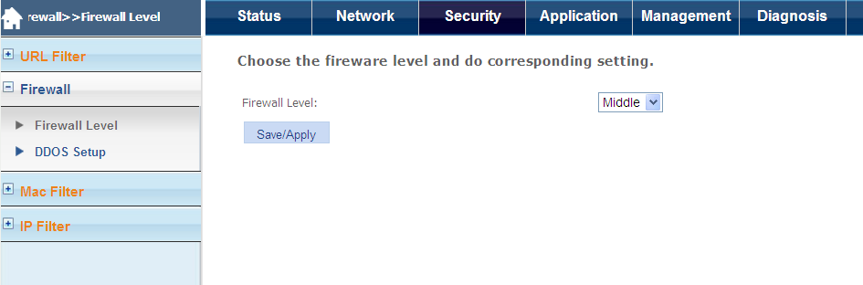

#### Enable dos attack to set the DOS protection or prevent port scanning on the DDOS Setup page.

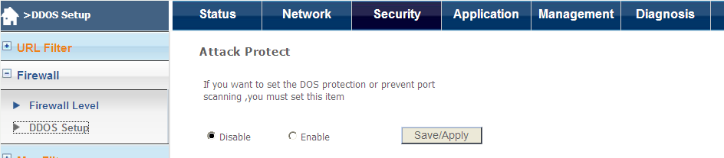

## **MAC filter**

* MAC (Media Access Control)address filtering Based on the user computer's MAC address to allow or deny access to LAN and the Internet. We can filter by MAC Filter to connect to the LAN port users and wireless users.

### Configure MAC filter

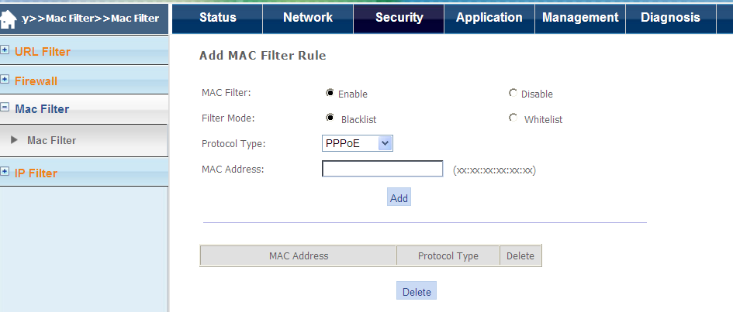

1. enable MAC filter.
2. select the filter mode :blacklist or white list.
3. select protocol type.
4. set the MAC in the text box.
5. click add to set up one MAC filter or delete to release . one filter.

## **IP filter**

* IP Filter

Use the IP address filter refused to specific IP addresses access to information on the Internet. You can deny specific ports or specific IP address of all ports. The screen will show the defined ports. Want to use them, you can choose edit item. You only need to enter the LAN IP address of the computer to access the Internet can be defined.

* IP

IP address of the client computer in the LAN to access Internet information. You can add an IP range or an IP address.

* Port

use a single port or a port range to define the Internet access. If you do not define a specific port, then all ports will be denied access.

Click the "Security" -> "IP filtering", in default, the firewall is enabled. Firewall is used to prevent files transmission between the Internet and the PC, . Certification of documents can only transfer to LAN side.

* Note

If the modem configuration bridge approach pvc, IP filtering is disabled. IP filtering interface is not displayed. If the modem is not configured to bridge mode pvc, MAC filtering is disabled, MAC filtering interface is not displayed.

### Configure IP filter

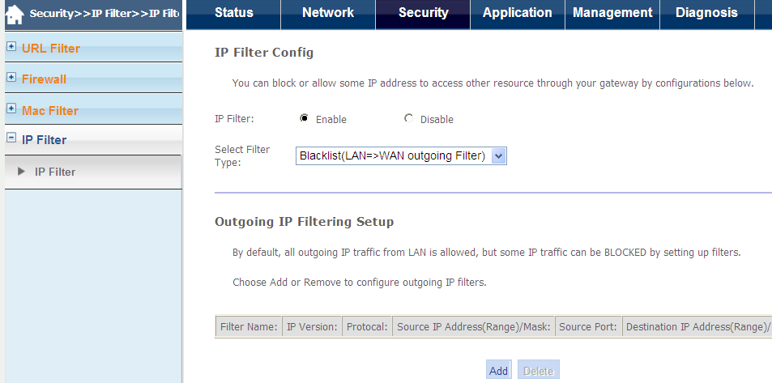

1. enable IP filter.
2. select filter type:blacklist or whitelist.
3. click add to add one filter.

# Application

## VOIP

* You can have a call over internet after doing some configuration in this part.

### Basic Setup

**Figure 8: basic setup about voice interface**

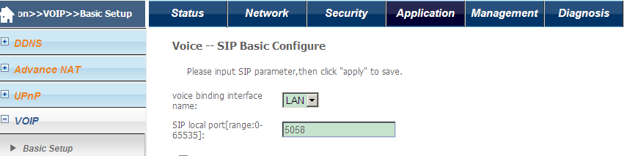

* In the voice binding interface name,the choose one you have configured for voice

**Figure 9: basic setup about voice**

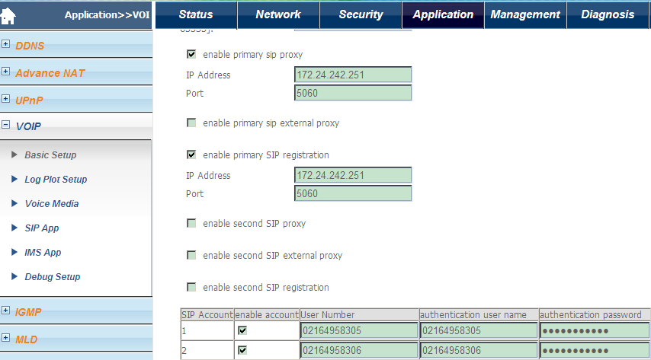

* Check enable primary sip proxy and input the proxy server address to the IP Address option,such as 172.24.242.251,
* Check enable primary sip registration and input the registration address to the IP Address option,for example 172.24.242.251.
* Check the enable account for both line1 and line2, and then Input the user number to the User Number table respectively
* For the authentication user name and authentication password,input the information which is used for authentication in register or Invite.

### [Log Plot Setup](http://192.168.1.1/voicesip_digitmap.html)

**Figure 10: digitmap setup**

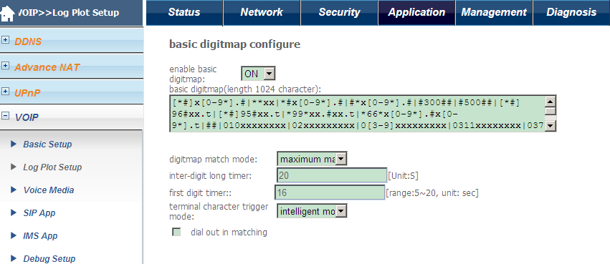

* input the digitmap you will use to the basic digitmap table

### [Voice Media](http://192.168.1.1/voicesip_voicemedia.html)

**Figure 11: voice media**

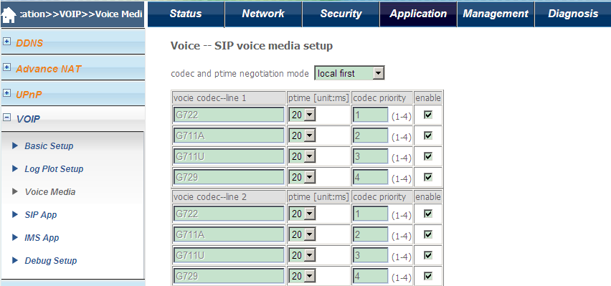

* You can choose the ptime and codec priority for the two lines

### [SIP App](http://192.168.1.1/voicesip_sip.html)lication

**Figure 12: Sip Application**

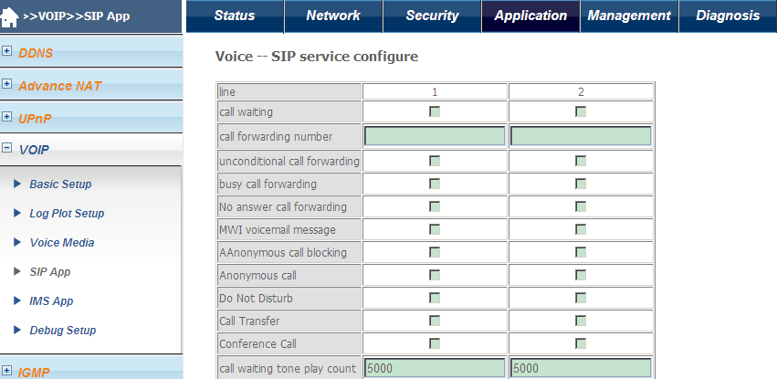

* You can enable the corresponding table when you need a [supplementary](app:ds:supplementary) [service](app:ds:service)

## **IGMP**

### IGMP Settings

* You can make the user can watch IPTV through the router program by set the IGMP Snooping, IGMP Proxy function.

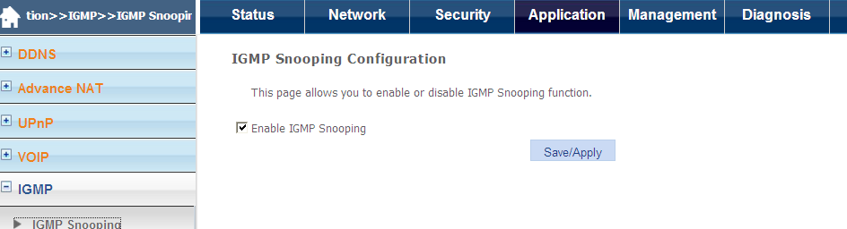

### Enable IGMP Snooping

* Select the group box to enable or disable IGMP Snooping.

# Diagnosis

## **Line Diagnosis**

### Ethernet connection Test

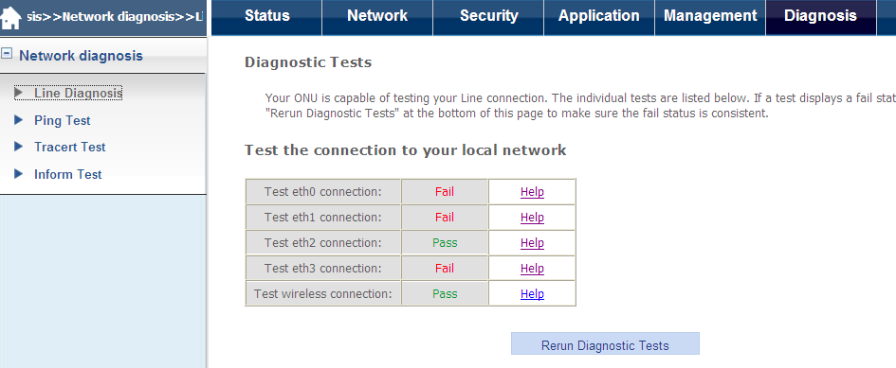

|  |  |
| --- | --- |
| Pass | Show that your computer's Ethernet port is connected to the LAN port of the ONU. ONU on the LAN indicator lights or flashes indicates that the Ethernet connection, the test was successful. |
| Failure | That ONU does not detect the computer's Ethernet interface. |

## **Ping Test**

The Ping test sends an IP ping to an IP address. The ping can be used to determine if another device can be accessed from the ONU.

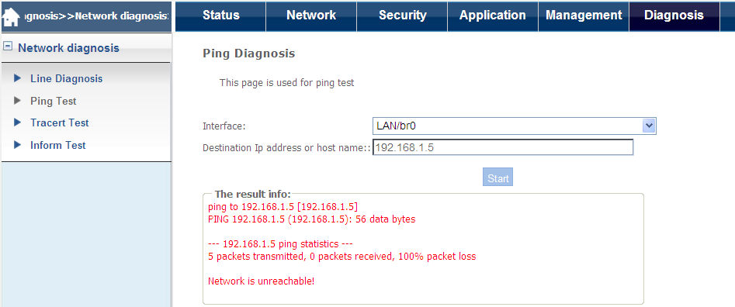

## **Inform Test**

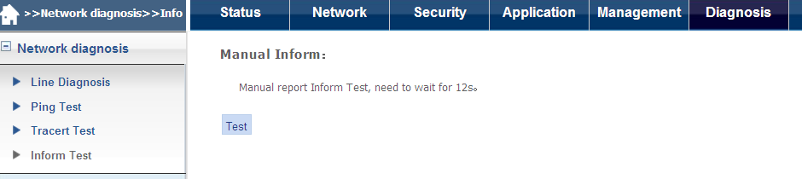

* Click on the "test " to test the CPE to the ACS of the reported situation.